STRUCTURE OF THE ATOM

The diagram below shows the way scientists saw the structure of the atom in the early 1900's.

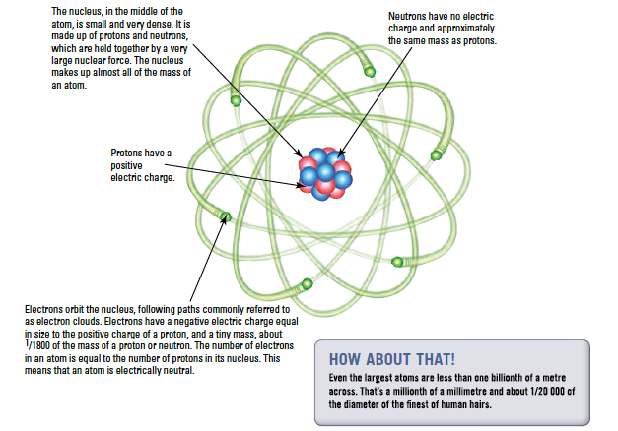

A scientist called Niels Bohr come up with a slightly different model where the electrons are found in energy shells around the nucleus.

Energy Shells - electrons are found in distinct energy shells around the nucleus.
Properties of Atomic Particles

PARTICLE | CHARGE | SIZE
proton | +1 | 1
neutron | 0 | 1
electron | -1 | ¹/₁₈₆₀

